SWOT Analysis of Namibia
Lina Daher
Institution:
20 February 2021

Introduction
Every nation has factors that it prides on as well as its own share of shortfalls and threats. From political stability, safety, economic performance, national values and the people, there are diverse aspects to review in ascertain the pros and cons of a country relative to others. From an investment point of view, undertaking a SWOT analysis is a vital exercise to know the culture, politics and economic aspects that make a nation unique. In this SWOT analysis, the analysis is on Namibia, a southwestern African nation bordering the Atlantic Ocean on the west and neighbors to Botswana, Zambia and South Africa. The relatively small populated nation is a former Germany colony that has taken bold steps towards economic transformation and improved performance of its key sectors. This papers will holistically review the totality of its economic, political and cultural factors to have better insights about the country. A summary of the SWOT factors is presented in Appendix 1 at the end of the paper.

The Areas of Strengths
Firstly, Namibia is home to a diversity of natural resources which mirror the richness and pride of all the Namibians. For instance, the Orange River washes down the alluvial diamonds from the Basotho highlands while southern regions like Arandis produce the precious uranium. It is one of the leading producers of uranium around the globe. Other minerals include magnesium, zinc, gold, silver, leas, copper and other precious stones. In fact the country has a vibrant mining sector that accounts for 12.5% of its Gross Domestic Product. The country also produces and exports cereal products such as rice and corn. By extension, despite the desert conditions, the weather conditions are favorable to support agricultural activities including crop farming and livestock keeping. Classified as an upper middle-income nation, Namibia agricultural sector contributes at least ten percent to its GDP.
Additionally, the country is one of the press-friendly on the continent. A 2017 KPMG report hailed the press freedom in Namibia as an incentive for better domestic and foreign investments. With free press, there is more information sharing and generally a less restrictive political environment. Then, the same report emphasizes that the rule of law is upheld in Namibia and therefore, constitutionalism is a favorable factor in the progression of the country. Besides, the people are loving and friendly to each other and foreigners. Instances of civil war are uncommon and the people are bound by their national values and oneness. The diversity of people, about 2.5 million, speaking over 30 languages is also a distinct characteristic of the Namibia. The people are hardworking and desire to achieve growth and progression as a society.
The Weaknesses
Like every other nation, Namibia has a set of its shortfalls. For instance, most of the people are below the poverty rate. Recent reports such as the 2019 Statistics Agency report showed that unemployment rates had surged to 29.9 percent while the poverty incidence stood at a high of 26.9 percent. This means more people are unable to fend for their needs and they directly feel the economic burdens. In line with the sustainable development goals, the Namibian government is doing enough to empower people out of abject poverty and chronic unemployment. In addition to that, Namibia has a tiny population of 2.5 million which is comparable to less populated states such as Mississippi or Kansas. From an economic standpoint, the small population limits the domestic market and thus slower economic growth. Talking about economic growth and empowerment, the Namibians including foreigners have immense barriers to business and entrepreneurship. These include among others inadequacy of skills, policy barriers, costly licenses, cultural mindsets and access to capital among others.
Opportunities for Growth and Development
One of the best initiatives by President Geingob’s administration is actively embracing ICT policies and digitization at all levels and throughout the sectors. The government has recognized the value of ICT infrastructure to attain socio-economic growth and has made significant investments to digitize the nation such as increasing broadband coverage. It has supported development of small and medium enterprises, such as through mobile payments and supported growth of sectors. Sectors such as agriculture has realized the important of smart farming which has raised dependence of agriculture to up to 70 percent. The government has also rolled out various incentives, such as tax incentives, to attract foreign direct investments especially in the manufacturing and export industries. In addition, the government has intensified commitment in developing key infrastructure such as million-dollar upgrades to air and sea ports. For instance, the Walvis Bay sea port was upgraded to a world-class and efficient port handling 3000 vessels carrying over 5.3 million tons of cargo every year. Due to this incentives and infrastructural investments, the Namibia economy has been growing steadily.

Threats to Namibia’s Growth & Progression
Firstly, Namibia’s economy is highly dependent on the South African economy and so its currency. The Namibia’s currencies are interchangeably used with South African rand. Due to this interdependence, the changes in the South African economy, such as the depreciation of the rand has a direct effect on the Namibian economy. Secondly, Namibia has been prone to natural hazards such as prolonged droughts since it is typically a desert nation. This has adverse impairment on sectors like agriculture where a significant portion of the farming communities depend on rains for food production. Therefore, production of food is critically impaired when droughts stay longer than anticipated. Finally, the emergency of the Covid-19 brought about many adverse effects including mass layoff to people resulting in reduced household incomes. Entrepreneurs also faced the harsh realities of the economy and growth slowly down for the better part of 2019 with their effects still felt today. Just like for other nations, the Covid-19 pandemic has realized stress to the growth of the Namibian economy.

Conclusion
Namibia is a South African nation with a small population but a well performing economy prior to the Covid-19 pandemic. Despite the desert-like conditions unfavorable to agriculture, limited economic capacity and a high poverty index, the country has made significant strides. The government has embraced digitization, provided more incentives to business and utilized its vast resources to grow the economy. Still there are immense opportunities in the development of infrastructure and more entrepreneurship initiatives to grow the economy. Nevertheless, the threats include dependence of the South African economy, prolonged droughts and the adverse impacts of the Covid-19 such unemployment and reduced incomes. The SWOT analysis has offered an ideal profile of the country and would inform decisions to invest or make visitation.

Appendices
Appendix 1: SWOT Analysis of Namibia
S | W
- Natural resources e.g. wildlife, diamonds, uranium  - Weather for agriculture  - Rule of law. Free press  - Hardworking, resilient people (diversity) | - High poverty rates  - Small pop, limited domestic market  - Low levels of economic incentives (barriers to entrepreneurship)
O | T
- Government Embracing ICT & digitization  - Several incentives to foreign investors  - Econ growth in recent years  - Better network opportunities, transport + internet, Walvis Bay sea port) | - Natural hazards (prolonged drought)  - Dependence on SA economy & currency  Setbacks of Covid-19 pandemic

Appendix 2: The Map of Namibia
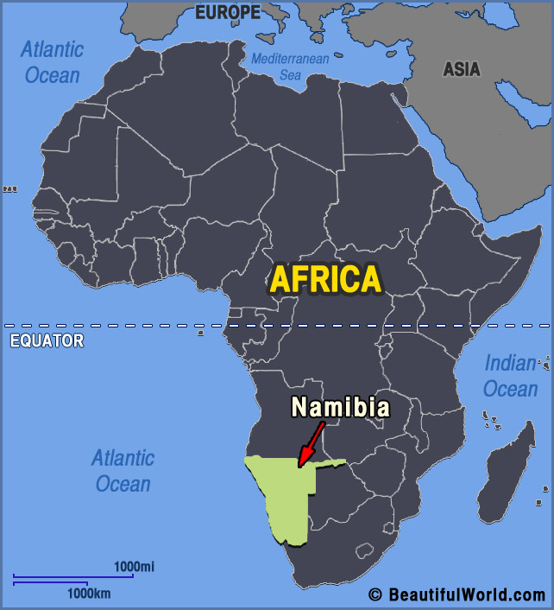

References
April, W. (2018). Entrepreneurial Orientation in Namibia: the Dolam Community. International Journal of Entrepreneurship and Small Business, 35(2):187-202 DOI: 10.1504/IJESB.2018.10016253
Brandt, E. (2019). ICT’s contribution to the Namibian economy. New Era Live. Retrieved on 19 February 2021 from https://neweralive.na/posts/icts-contribution-to-the-namibian-economy
CCAFS report (2015). Namibia country climate-smart agriculture program. Climate Change, Agriculture and Food Security Organization. Retrieved on 19 February 2021 from https://ccafs.cgiar.org/resources/publications/namibia-country-climate-smart-agriculture-program
CIA Fact book. (2021). Countries: Namibia. Cia.gov. Retrieved on 19 February 2021 from https://www.cia.gov/the-world-factbook/countries/namibia/
Discover Africa (2017). 10 Interesting Facts about Namibia. Retrieved on 19 February 2021 from https://www.discoverafrica.com/blog/10-interesting-facts-about-namibia/
Encyclopedia Britannica, Inc. (2021). Geography & Travel> Countries of the World >Namibia. Retrieved on 19 February 2021 from https://www.britannica.com/place/Namibia/The-road-to-Namibia
Grant, R., & Krugel, L. (2017). Namibia Economic Snapshot H2, 2017. Report by KPMG Services Pty Ltd. Retrieved on 19 February 2021 from https://assets.kpmg/content/dam/kpmg/za/pdf/2017/12/Namibia-2017H2.pdf
Jonas (2021). COVID-19 threatening the Jobs, Health and Living Environment of Namibian Workers. Friedrich-Ebert-Stiftung e.V. Retrieved from https://www.fes.de/en/e/covid-19-threatening-the-jobs-health-and-living-environment-of-namibian-workers
Namport (2021). Welcome to the Port of Walvis Bay. Retrieved from https://www.namport.com.na/ports/welcome-to-the-port-of-walvis-bay/522/
Ngatjiheue, C. (2019). Severe poverty still haunts Namibians. The Namibian. Retrieved on 19 February 2021 from https://www.namibian.com.na/191489/archive-read/Severe-poverty-still-haunts-Namibians

Encyclopedia Britannica, Inc., (2021). Retrieved from https://www.britannica.com/place/Namibia
CIA Fact book, (2021). Retrieved from https://www.cia.gov/the-world-factbook/countries/namibia/
Discover Africa (2021) - The landmass of Namibia is largely occupied by the Namib Desert, the 55 million year desert leaving only about less than 10% of land for farming.
CIA Fact book, (2021) - Despite a 10% contribution to GDP, between 25-40% of Namibia’s population depend on agricultural activities for their livelihoods.
Grant & Krugel (2017), p. 1
Ibid, p. 1
Ngatjiheue (2019). Retrieved from https://www.namibian.com.na/191489/archive-read/Severe-poverty-still-haunts-Namibians
Grant & Krugel (2017), p. 1
Ibid, p. 1
April (2018) - the policy barriers have improved but not to sufficient levels.
Brandt (2019). Retrieved from https://neweralive.na/posts/icts-contribution-to-the-namibian-economy
CCAFS Report (2015) - Climate Smart agriculture is transforming the economic conditions of hundreds of thousands of Namibians.
Grant & Krugel (2017), p. 1
Namport (2021). Retrieved from https://www.namport.com.na/ports/welcome-to-the-port-of-walvis-bay/522/
Grant & Krugel (2017), p. 1
Jonas (2021). Retrieved from https://www.fes.de/en/e/covid-19-threatening-the-jobs-health-and-living-environment-of-namibian-workers

